COMPUTER NETWORKS

BCSE308P

LAB WORK - 6

NAME: Adhithya Kumar Tummala

REG NO: 24BCE1588

CHECKSUM :

Method-1: The validate checksum option available in wireshark

1) View -> Preferences -> Select required protocols -> Turn on Valitdate check sum if possible
Example:
TCP:

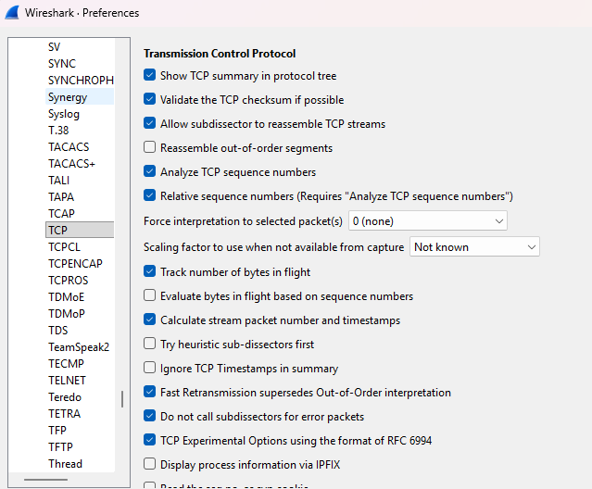

Ipv4:

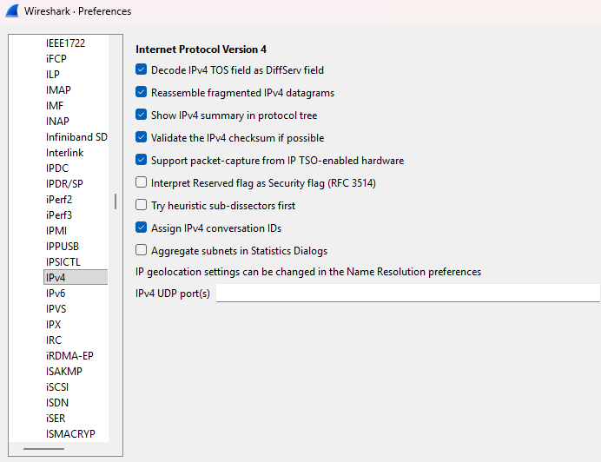
2) Right click on TCP protocol -> Preferences -> Validate checksum if possible

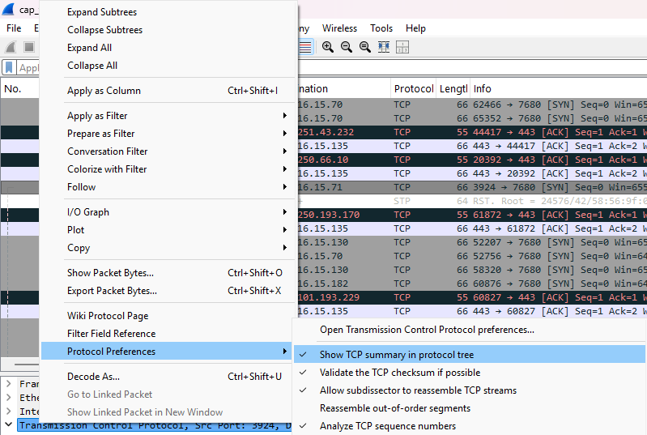
Validation :
1)TCP:
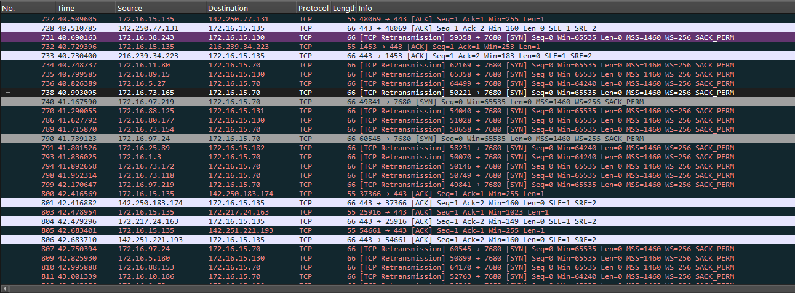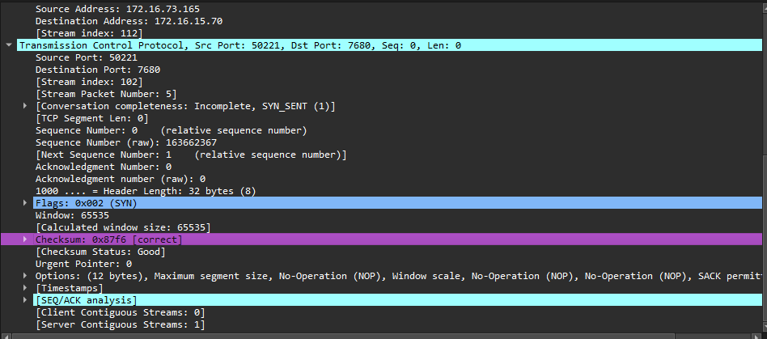

2)UDP:
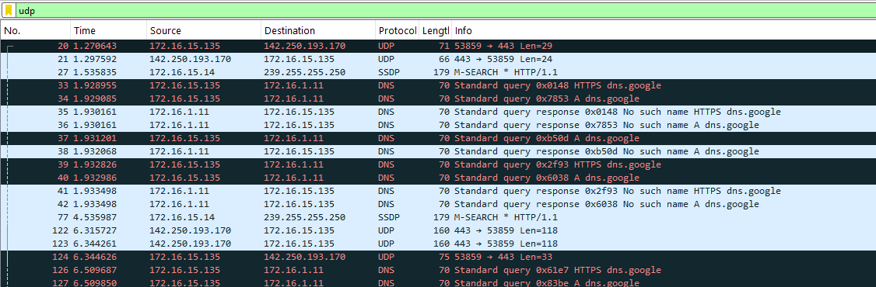
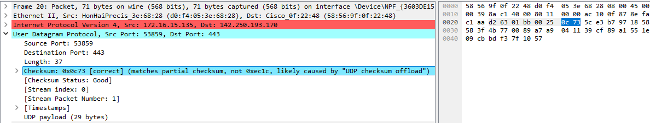

3) IPv4:
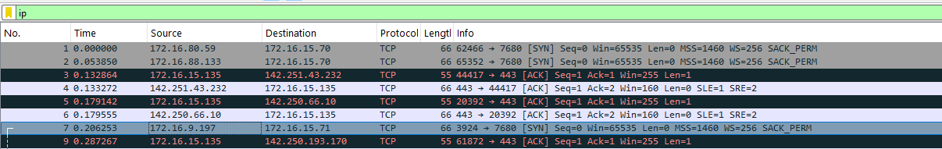

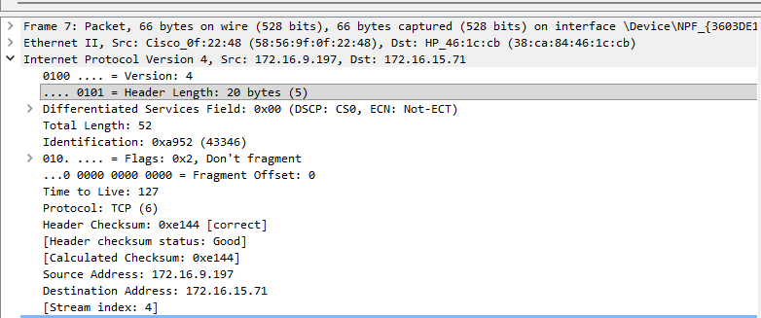
4)ICMP:

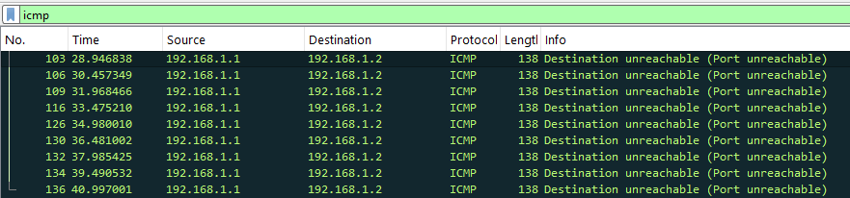
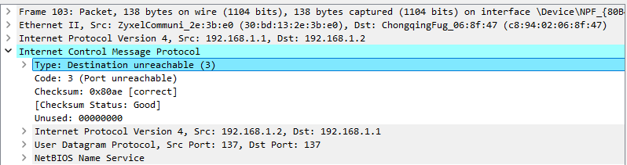

5)IGMPv2:

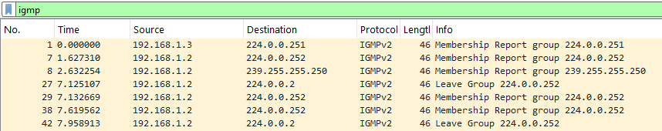

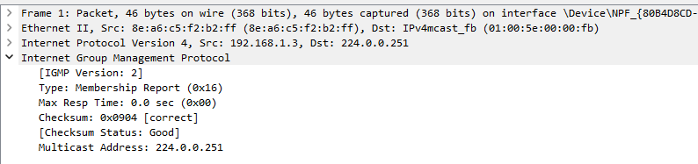
Method-2: (Manually Verifyed Carrysum)
IPv4:
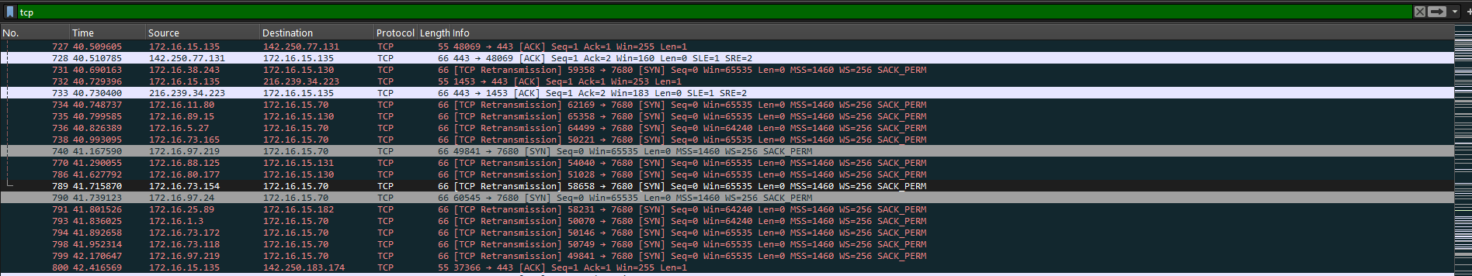

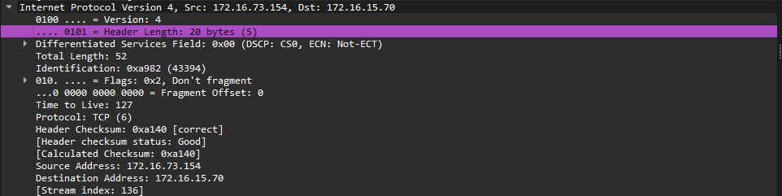

Manual Verification:
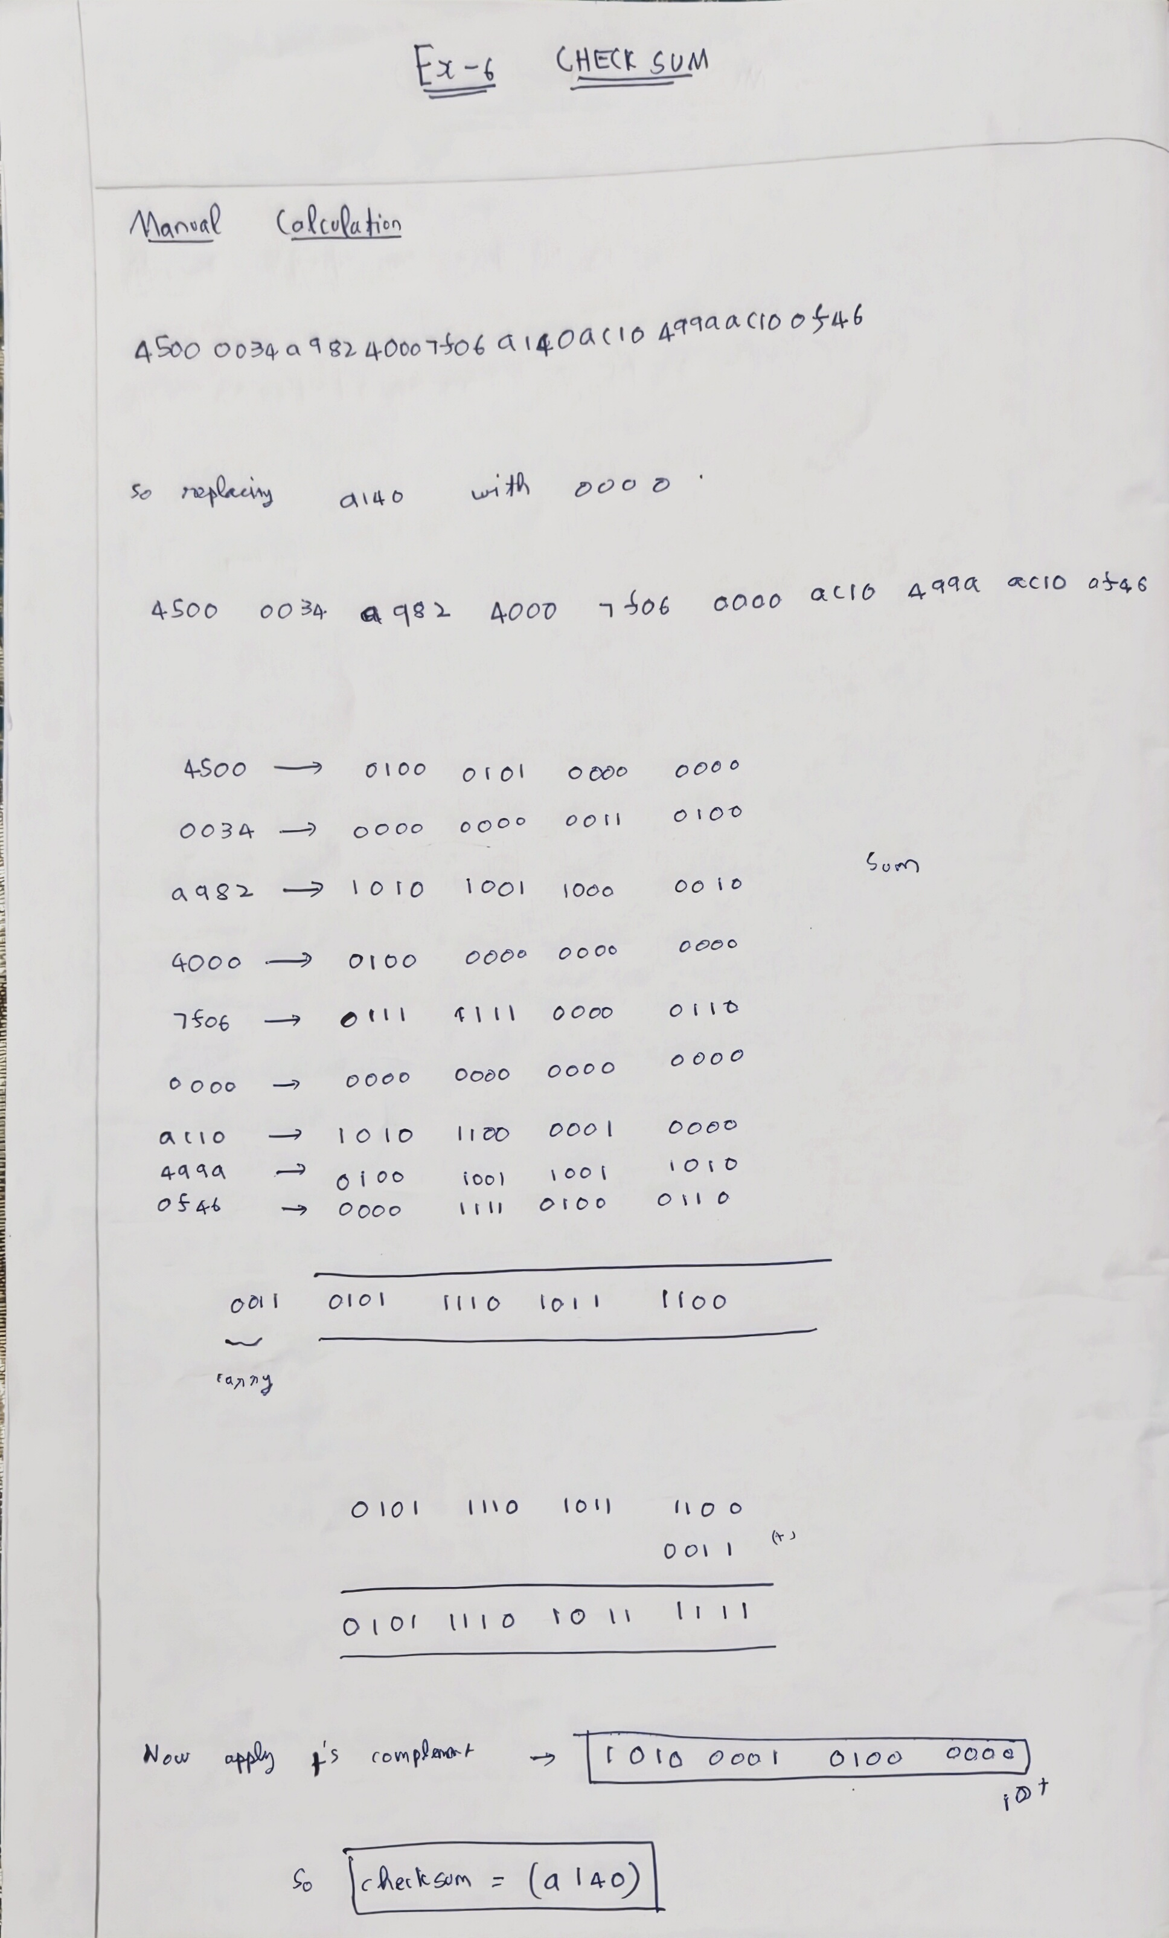

Hence the validated checksum is matching with the answer .

Method-3:
Code:
from scapy.all import *
import sys
import os
def validate_checksums(pcap_file):
try:
print(f"[*] Loading {pcap_file}...")
packets = rdpcap(pcap_file)
except FileNotFoundError:
print(f"[!] Error: File {pcap_file} not found.")
return
print(f"[*] Analyzing {len(packets)} packets...\n")
print(f"{'Packet #':<10} | {'Protocol':<10} | {'Status':<10} | {'Original':<10} | {'Calculated':<10}")
print("-" * 65)
for i, pkt in enumerate(packets):
packet_num = i + 1
# --- Layer 3: IP Checksum Validation ---
if IP in pkt:
proto_name = "IP"
original_chksum = pkt[IP].chksum

# Recalculate IP Checksum
temp_pkt = pkt.copy()
del temp_pkt[IP].chksum
temp_pkt = IP(raw(temp_pkt[IP]))
calc_chksum = temp_pkt.chksum

match = original_chksum == calc_chksum
status = "VALID" if match else "INVALID"
print(f"{packet_num:<10} | {proto_name:<10} | {status:<10} | {hex(original_chksum):<10} | {hex(calc_chksum):<10}")

# --- Layer 4: TCP / UDP / ICMP Checksum Validation ---
l4_layer = None
if TCP in pkt:
l4_layer = TCP
proto_name = "TCP (TLS)" if pkt[TCP].dport == 443 or pkt[TCP].sport == 443 else "TCP"
elif UDP in pkt:
l4_layer = UDP
proto_name = "UDP"
elif ICMP in pkt:
l4_layer = ICMP
proto_name = "ICMP"

if l4_layer:
original_chksum = pkt[l4_layer].chksum

# Recalculate Layer 4 Checksum
temp_pkt = pkt.copy()
del temp_pkt[l4_layer].chksum

# Force recalculation by refreshing the packet raw bytes
# This handles the Pseudo-header automatically via Scapy
temp_pkt = temp_pkt.__class__(raw(temp_pkt))
calc_chksum = temp_pkt[l4_layer].chksum

match = original_chksum == calc_chksum
status = "VALID" if match else "INVALID"
print(f"{packet_num:<10} | {proto_name:<10} | {status:<10} | {hex(original_chksum):<10} | {hex(calc_chksum):<10}")

if __name__ == "__main__":
# Ensure this filename matches your actual Wireshark save file
pcap_filename = "cap_files.pcap.pcapng"

if not os.path.exists(pcap_filename):
print("Creating dummy pcap for demonstration...")
dummy_pkts = [
IP(dst="8.8.8.8")/TCP(),
IP(dst="1.1.1.1")/UDP(),
IP(dst="8.8.8.8")/ICMP()
]
wrpcap(pcap_filename, dummy_pkts)
validate_checksums(pcap_filename)

Output:
- Checking For Tcp and Ip protocols :
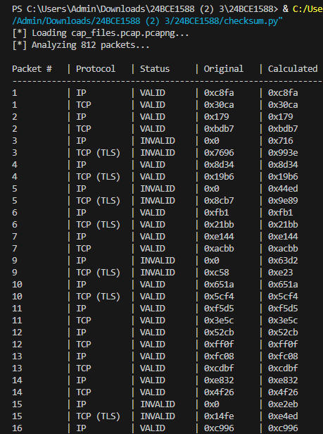

- Checking for Tls and Udp protocols:
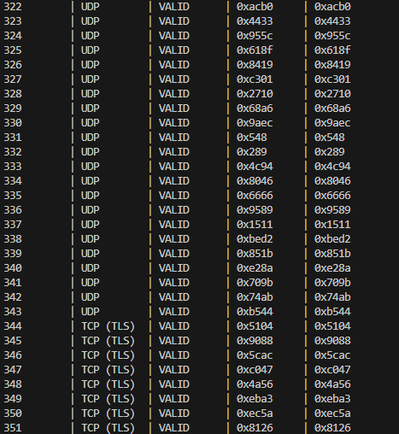

3) Checking for Icmp protocols:
